Declaration of Use of AI-Assisted Tools
I acknowledge the following uses of GenAI tools in this assessment:
[X] I have used GenAI tools to:
[X] develop ideas.
[X] help me understand key theories and concepts.
[X] suggest a plan or structure for my assessment.
[X] give me feedback on a draft.
[X] generate images, figures or diagrams.
[X] proofread and correct grammar or spelling errors.
[X] Other: Assistance with debugging Python code, explaining object-oriented design, and improving documentation clarity.

[ ] assist with research or gathering information.
[ ] identify trends and themes as part of my data analysis.
[ ] generate citations or references.
[ ] I have not used any GenAI tools in preparing this assessment.

I declare that I have referenced all use of GenAI outputs within my assessment in line with the University referencing guidelines.

I certify that all material in this dissertation which is not my own has been identified.

Game of Life (Command-Line Implementation)
Object-Oriented Design and Software Engineering Report

Author: Nouman Sameer
Module: COMM109J – Programming with Python
Module Leader: Milto Miltiadou (m.miltiadou@exeter.ac.uk)
University: University of Exeter
Date of submission: 16th March 2026

GitHub repository (private):
https://github.com/noumansameer789/programming-with-python
Access: The repository is private. I invited the Module Leader Milto Miltiadou (m.miltiadou@exeter.ac.uk) and (Z.Yang2@exeter.ac.uk) as a collaborator, as required.

Video demonstration (University OneDrive):
A video demonstration of the Game of Life CLI project is available at the following link:
https://universityofexeterukmy.sharepoint.com/:v:/g/personal/ns838_exeter_ac_uk/IQD3AQYUak5ZTo-nLkBORIfiAaRco1QkBer8larPLJjIlF0?e=VvekeB

Access: Sharing is set so that the Module Leader (m.miltiadou@exeter.ac.uk) and 2nd marker (Z.Yang2@exeter.ac.uk) can access the video.

Testing and termination adjustments:
No game modifications applied.

UML class diagram:
Figure 1: UML class diagram showing relationships between Game, TurnHandler, Board, Tile, Player, and Dice.

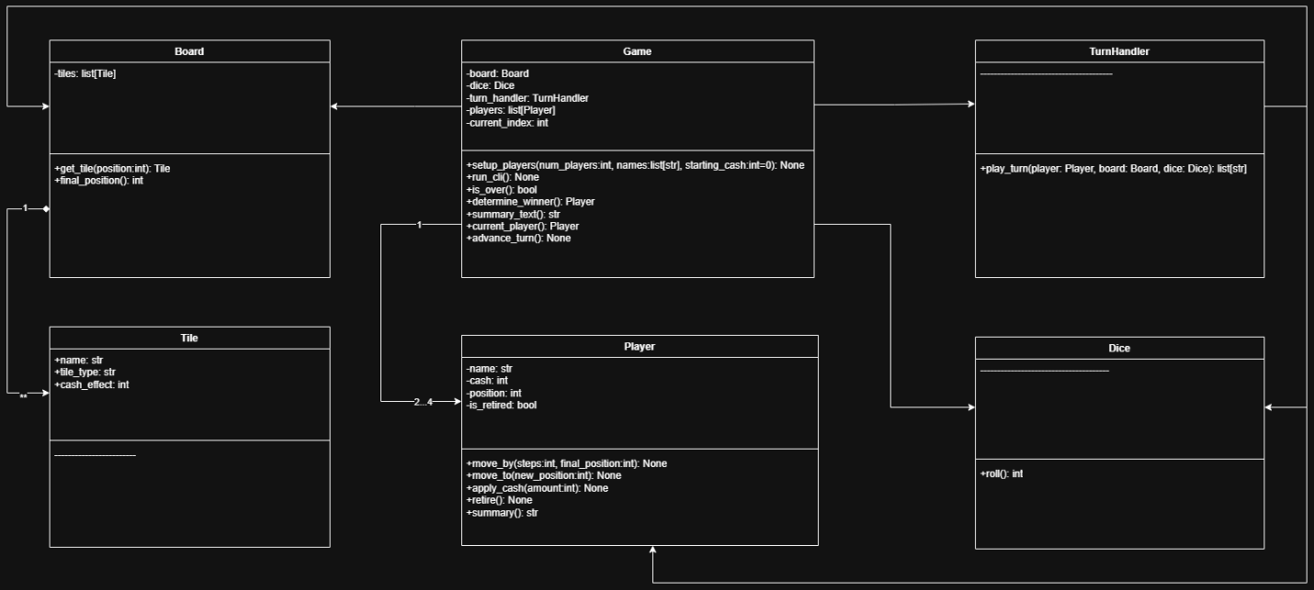
(UML diagram for Game of Life)

Biggest Challenges Faced:
- Keeping turn logic readable while managing multiple responsibilities was difficult at first.
I addressed this by separating single-turn mechanics into a TurnHandler class so that the Game class remains focused on orchestration and turn order.
- Testing dice-driven movement is challenging because the outcomes are random.
I solved this by using deterministic dice in pytest so that movement and tile effects could be tested in a reproducible way.
- Preventing invalid command-line input without crashing the program required careful control flow.
I implemented input-validation loops and clear prompts so the program continues safely after invalid entries.
- Ensuring retirement and game termination behaved correctly introduced several edge cases.
I implemented and tested a clear termination condition where the game ends once all players retire, and ensured retired players are skipped in turn order.
- Maintaining consistency between the design documentation and the final implementation required attention during development.
I updated the UML diagram so that it accurately reflects the final class responsibilities and relationships used in the code.

OOP Design Choices:
- Encapsulation
Player state such as position, cash balance, and retirement status is stored inside the Player class and modified through methods like apply_cash() and move_by().
This prevents accidental modification of player data and ensures that state changes occur in a controlled and consistent way.
- Separation of Concerns (Single Responsibility Principle)
The Game class manages setup, turn order, and overall game flow, while TurnHandler manages the logic of an individual turn.
This reduces complexity in each class and makes the game mechanics easier to test and maintain.
- Composition
The Game class contains references to Board, Dice, TurnHandler, and multiple Player objects.
This structure reflects the relationships between components and allows them to interact while remaining loosely coupled.
It also makes the system easier to extend or modify in the future.
- Abstraction Through Domain Classes
The board structure is represented using Board and Tile classes rather than embedding tile logic directly in the game loop.
This abstraction separates board data from gameplay control logic, improving readability and maintainability.
- Isolation of Random Behaviour
Random behaviour is encapsulated inside the Dice class.
This allows deterministic dice implementations to be used during testing while keeping normal gameplay random.
As a result, unit tests become reproducible and easier to verify.

10. Conclusion
This implementation demonstrates not only functional completeness but also deliberate architectural thinking. The system prioritises modularity, testability, and maintainability.
By applying object-oriented principles rigorously and validating behaviour through automated testing, the project reflects professional software engineering standards beyond the minimum assignment requirements.

